

ANALYSTLAB AFRICA
Data Science Internship Programme

Five workforce observations

- Research & Development and Sales departments account for the highest number of employees, with Human Resources records the lowest attrition count
- Laboratory Technician, Sales Executive, sales representatives, and Research Scientist experience noticeably higher employee attrition than others.
- employees who work overtime are more likely to leave the organization than those who do not
- The company has a predominantly mid-career workforce.
- Most employees earn relatively lower monthly incomes, while a smaller number earn significantly higher salaries.

Five possible factors contributing to attrition supported by evidence.

- Employees who left the organization generally have a lower median monthly income.
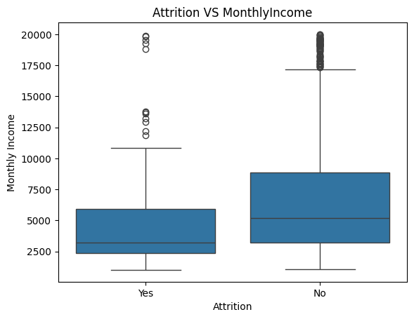

- Employees who left the organization appear to have a slightly lower median age.

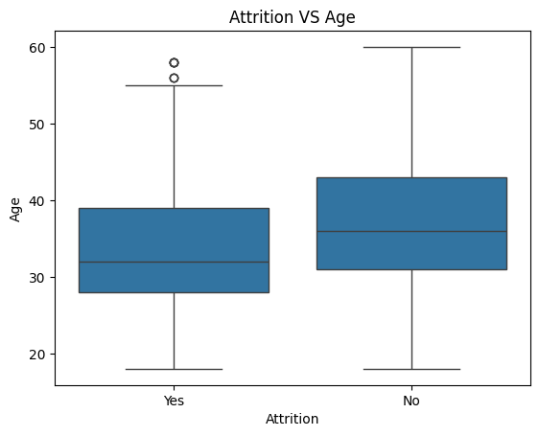

- Employees who work overtime are more likely to leave the organization.
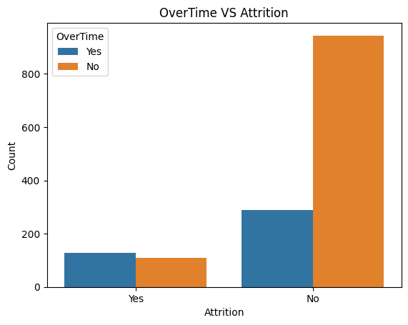

- Laboratory Technician, Sales Executive, sales representatives and research Scientist experience noticeably higher employee attrition..
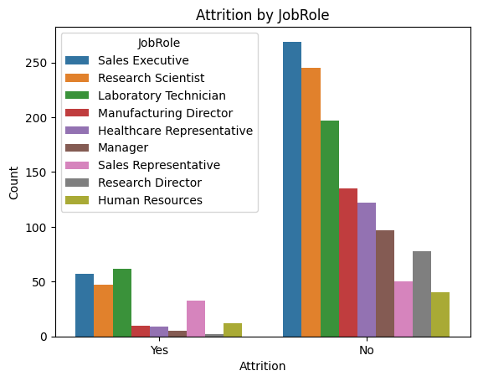

- Research & Development and Sales departments account for the highest number of employees leaving the organization.
